Data Representation

Some binary representations of data:
1.BCD code
→ Each decimal number is represented by 4 bit number
2.Gray Code
→ Each bit is x-or’d to the front bit
3.Self complimenting code
→ The number is complimented
4.Weighted code
→ Each bit in the number has a weight asigned to it like the 1 in 100 has weight 100
5.Access 3 code
→ 3 is added to the number
6.EBCDIC code
→ Standard before ASCII
7.ASCII code
→ Binary representation for charecters and some special symbols where each character takes 7 bits
8.Unicode
→ Modern standard for representing symbols and charecters where each bit take 64 bits

Grey code:
Decimal | Binary | Gray code
1 | 1 | 1
2 | 10 | 11
3 | 11 | 10
4 | 100 | 110
5 | 101 | 111
6 | 110 | 101
7 | 111 | 100
8 | 1000 | 1100
9 | 1001 | 1101

ASCII code :
Uppercase | code | Lowercase | code | Digits | code
A | 65 | a | 97 | 0 | 48
B | 66 | b | 98 | 1 | 49
C | 67 | c | 99 | 2 | 50
D | 68 | d | 100 | 3 | 51
... | ... | ... | …. | ... | ….
Z | 90 | z | 122 | 9 | 87

Unicode:
some of the standars are:
1.UTF8
2.UTF16

1’s compliment → flip the bits
2’s compliment → flip the bits and add one
9’s compliment → subtract each digit from 9
10’s compliment → subtract each digit from 9 and add one

Floating point representation:
any number in decimal form (ex 1.21) in floating point representation will be
0.121x10¹ where the red number is exponent , blue number is base, yellow number is significand and green number is fraction part.
Sign | Exponent | Significand
1 bit | 8 bit | 23 bit
The exponent is biased with 127 to represent negetive numbers.

Example:
3.1 = 11.000110…
Changing it in normalized form:
1.10001100011...x2¹
floating point format(no biasing)
0 00000001 10001100011000110001100
Green = signed bit
Red = exponent
Yellow = Mantissa/significand

Error Checking using parity:
Parity is the number of 1 bit in a data. If checking for even parity there must be even number of 1 bit and if checking for odd parity there must be odd number of 1 bit. The parity is checked using a extra parity bit.

Parity generator:
P = (x xor y xor z)’
messege p-bit
001 0
011 1
100 0
101 1
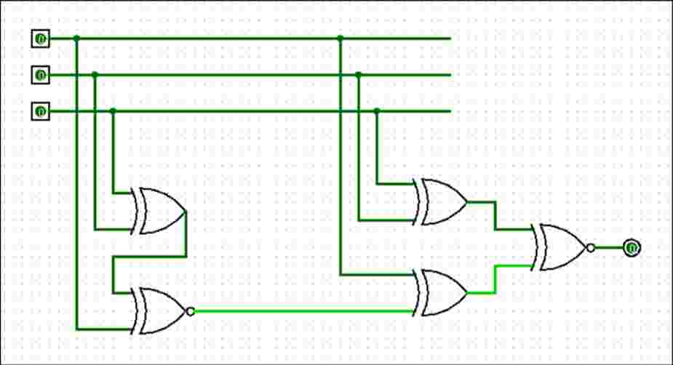

Parity Checker:
e = (p xor x xor y xor z)’

Multiplication:
Signed magnitude multiplication:
Flowchart of multiplication:

Multiplicand in B
Multiplier in Q

A_{s} ← Q_{s} xor B_{s}
Q_{s} ← Q_{s} xor B_{s}
A ← 0 , E ← 0
SC ← n-1

0 1
EA ← A+B
Q_{n}

Shr EAQ
SC ← SC -1

SC
1

0

END

Example:
multiplicand (B) = 10111
multiplier (Q) = 10011
SC | E | A | Q | operation
5 | 0 | 00000 | 10011 | initialization
 | 0 | 10111 | 10011 | Q_{n} is 1 so EA ← A+B
4 | 0 | 01011 | 11001 | Shr EAQ , SC ← CS-1
 | 1 | 00010 | 11001 | Q_{n} =1 so EA ← A+B
3 | 0 | 10001 | 01100 | Shr EAQ , dcr SC
2 | 0 | 01000 | 10110 | Shr EAQ , dcr SC
1 | 0 | 00100 | 01011 | Shr EAQ , dcr SC
 | 0 | 11011 | 01011 | Q_{n} = 1 EA ← A+B
0 | 0 | 01101 | 10101 | Shr EAQ , dcr SC
Product = 0110110101

Booth’s Multiplication(Signed multiplication):
flowchart in phone

Multiply -9 x -13
here,
multiplicand(B) = 01001 → 10111 (2’s compliment represent -ve )
multiplier(Q) = 01101 → 10011 (2’s compliment represent -ve )
SC | A | Q | Q_{n+1} | operation
5 | 00000 | 10011 | 0 | init
4 | 01001 | 10011 | 0 | Qn Qn+1 = 10, A+B’+1→ A
 | 00100 | 11001 | 1 | Ashr AQQn+1, dcr SC
3 | 00010 | 01100 | 1 | Ashr AQQn+1, dcr SC
 | 11001 | 01100 | 1 | Qn Qn+1 = 01 , A+B→ A
2 | 11100 | 10110 | 0 | AshrAQQn+1,dcrsc
1 | 11110 | 01011 | 0 | Ashr AQQn+1, dcr SC
 | 00111(discard carry) | 01011 | 0 | Qn Qn+1 = 10, A+B’+1→ A
0 | 00011 | 10101 | 1 | Ashr AQQn+1, dcr SC
Product = 00011101011 → 117

